QUESTION 1
Use Newton’s method for following equations to find a root. You must use specific starting value.
- F(x) = -5x⁴ + 11x² – 2 x₀ = 1
- F(x) = x⁵ - 0,5 x₀ = 1

Solution (a):
clear all
close all
clc
syms x;
f = @(x) (-5)*x^4 + 11*x^2 - 2; % Our equation
x0 = 1;
z = f(x);
diffZ = diff(z); % Derivative of f(x)
numZ = subs(z,x,x0);
denZ = subs(diffZ,x,x0);
x0 = x0 - double(numZ)/double(denZ); % Newton Raphson Formula
r = x0;
fprintf('Approximate Root is %.1f\n',r);

Output (a):

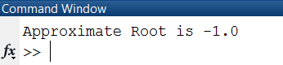

Solution (b):
clear all
close all
clc
syms x;
f = @(x) x^5 - 1/2 ; % Our equation
x0 = 1;
z = f(x);
diffZ = diff(z); % Derivative of f(x)
numZ = subs(z,x,x0);
denZ = subs(diffZ,x,x0);
x0 = x0 - double(numZ)/double(denZ); % Newton Raphson Formula
r = x0;
fprintf('Approximate Root is %.1f\n',r);

Output (b):

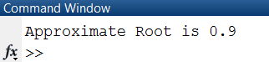
QUESTION 2
Find the zeros of the following Legendre Polynomials.

- P₃(x) = (5x³ – 3x)/2
- P₅(x) = (63x⁵ – 70x³ + 15x)/8

Solution (a):
clear all
close all
clc
x = -1:.002:1;
P3 = (5*x.^3 - 3*x)/2; % Legendre Polynomial
plot(x,ones(size(x)),x,x,x,P3)
legend('P_0(x)','P_1(x)','P_3(x)','location','southeast')
grid on;
xlabel x;
ylabel y;
axis([-1 1 -1.2 1.2]);
zero_points = [-0.77 0 0.77]
hold on
plot(zero_points,zeros(1,3),'o','markersize',12,'linewidth',3.0);
hold off;

Output (a):
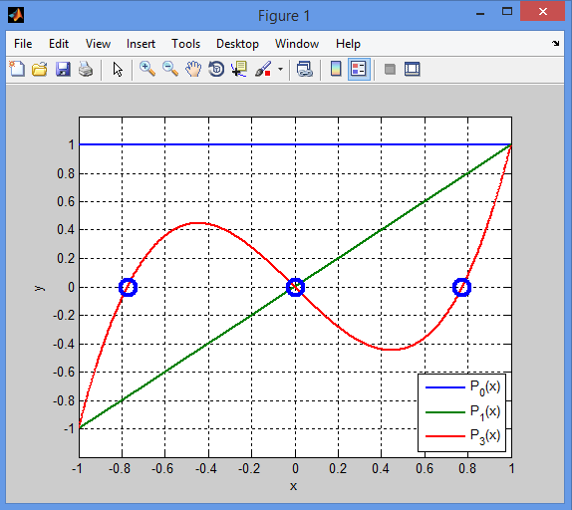
Solution (b):
clear all
close all
clc
x = -1:.002:1;
P5 = (63*x.^5 - 70*x.^3 + 15*x)/8; % Legendre Polynomial
plot(x,ones(size(x)),x,x,x,P5)
legend('P_0(x)','P_1(x)','P_5(x)','location','southeast')
grid on;
xlabel x;
ylabel y;
axis([-1 1 -1.2 1.2]);
zero_points = [-0.91 -0.54 0 0.54 0.91]
hold on
plot(zero_points,zeros(1,5),'o','markersize',12,'linewidth',3.0);
hold off;

Output (b):
